Online Gallery - Project Proposal

S222476598 – Devina Stephanie Selamat

SIT-120 | Introduction to Responsive Web Apps

# Product Summary

I plan to make an Online Gallery for artists, which means artists will be able to publish their art in the online gallery and build their name in the gallery. The artist will also be able to put their other social media and contact info. The Online Gallery will serve to be more of an online portfolio platform, and all artists will be able to post their masterpieces in the Online Gallery.

I also want to add a function where artists will also be able to show themed exhibitions. (My original plan is to allow 3D to be showcased within the Online Gallery, however I can’t do that right now so only 2D static art within the Online Gallery for now).

Artists will need to make an account and go through rigorous verification before they are able to formally be an artist in the Online Gallery. Viewers don’t have to have an account to view Online Galleries, but I want to add a feature where Artists only let Viewers with accounts or Viewers who ‘follow’ the artist into the Online Gallery.

## Assets :

1. Index.html - > Main framework, the base of the website
2. Style.css - > Website design will rely on this
3. Main.js - > the main framework for Javascript for the Vue components
4. App.vue - > Single file component and the base for the Vue component
5. Navigation.vue - > Single responsive file component used to navigate the website
6. Home.vue - > Single interactive file component, can be seen regardless whether the user is logged in or not
7. Find.vue - > Single interactive file component, searchbar used to find exhibitions or artists
8. Exhibitions.vue - > Single responsive component list, displaying all the open exhibitions
9. Exhibition.vue - > Single responsive file component, a page of a specific exhibition in the website.
10. Profile.vue - > Single responsive file component, a profile page of a specific user selected, there will be a follow interaction instead of ‘edit’ interaction here.
11. Profiles.vue - > Single responsive component list, displaying all artists filtered by the search bar.
12. User.vue - > Single responsive file component, a profile page of the user, and have the option to ‘edit’ instead of a follow interaction.
13. Edit.vue - > Single interactive file component, an editing page for the user profile, including social media list and ‘about me’
14. Edited.vue - > Single file component, the page after profile edit has been updated
15. Upload.vue - > Single file component, image upload page (1 image at a time), including name, date of completion, tags, image frames and a short description
16. Uploaded.vue - > Single file component, the page after the image have been uploaded
17. Event.vue - > Single file component, exhibition editor with background, logo, visitor entry filter and more text customization, cancel or close exhibitions from this page too.
18. Held.vue - > Single file component, the page after the exhibition have been successfully launched.
19. About.vue - > Single file component, website’s ToS and description
20. Contact.vue - > Single interactive file component, website’s customer service page
21. Submitted.vue - > Single file component, the page after customer service help form is submitted
22. Login.vue - > Single file component, log in page, will use 2FA
23. Logout.vue - > Single file component, the page after the user have successfully logged out
24. Registration.vue - > Single file component, registration page, will use email authentication

# Product Purpose

## Target Audience :

1. Artists : Some artists don’t have the capital to rent physical locations to hold exhibitions, but the Online Gallery is free. Some other artists would also like to hold exhibitions online for their own personal reasons.
2. People who want to appreciate art : Some people want to appreciate art but can’t go out of their homes or don’t feel safe going out of their homes. They can view art in the Online Gallery.
3. Schools : Schools can use the Online Gallery to do online exhibitions of their students’ works.
4. People who want to make a portfolio : They can use the Online Gallery to make a portfolio for school, work, etc.

## Creative Approach

* A lot of available customization  
  Users will be able to deliver an exhibition experience to their liking. This will allow artist users to create an experience unique to each of them, or unique to their themes.
* Simple minimalistic design  
  The original design from the website will be simple and minimalistic, acting as a blank canvas for the artists holding an exhibition. However, the other purpose of the minimalistic design is to be pleasing to the eye.
* Profile picture and short self-description  
  A unique profile picture and a self-description where an artist can promote themselves and include their social media, or regular art enjoyers can find other like-minded users and bond over the exhibitions held by the Online Gallery.

# Target Behavior

## Components

1. List Rendering – I will use this asset in the find page in order to list out other user datas.
2. Conditional Rendering – I will use this asset in order to show exhibition availability (to the general public, registered users only, or following registered users only), and to update following and exhibition views in real time.

## User Story (From Most Important to Least Important)

1. I want to be able to make an account. - > Vue.js registration and log in
2. I want to be able to share my art. - > Picture upload feature (JPEG and PNG), Artist registration, art display for artists (Also include adding name and date of completion)
3. I want to be able to see art - > Art display for viewers (including art name, date of completion and artist name.
4. I want to be able to hold exhibitions - > Separate art display for exhibition purposes.
5. I want to be able to customize my exhibitions - > Upload exhibition background, a feature to add a small caption on every artwork, a feature to upload exhibition logo, a feature to customize frames
6. I want to be able to limit the people who can enter my exhibition - > a feature to verify if the viewer fulfills the conditions set by the artist
7. I want to be able to follow an artist -> Follow feature
8. I want to be able to share my social media and details - > A space to share some information in the account customization
9. I want to be able to customize my account -> Account customization feature

# UX/UI Design

## Design

The website itself will have a grayscale color, mainly in white, black and grey with a minimalistic style that will accommodate all types of art in one website. Artists who want to hold exhibitions will be able to customize their exhibition but other than the exhibition itself, the other page will be in grayscale.

The design down below is a prototype and the final product might look different.

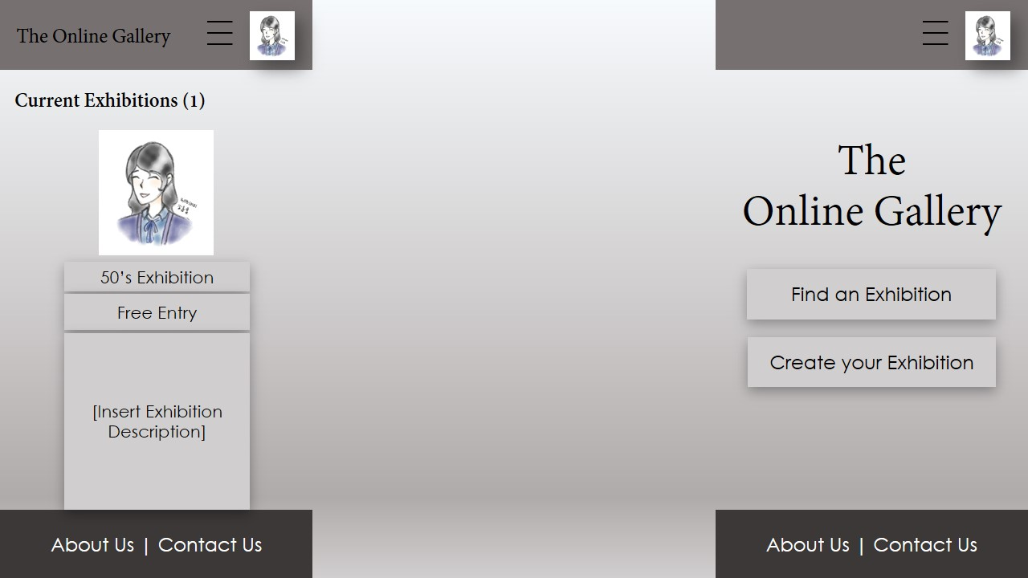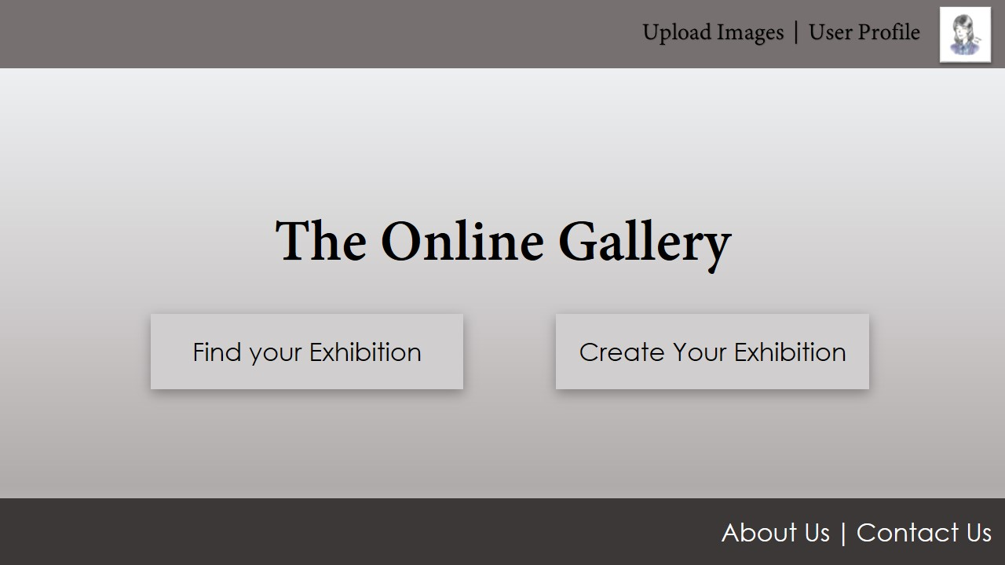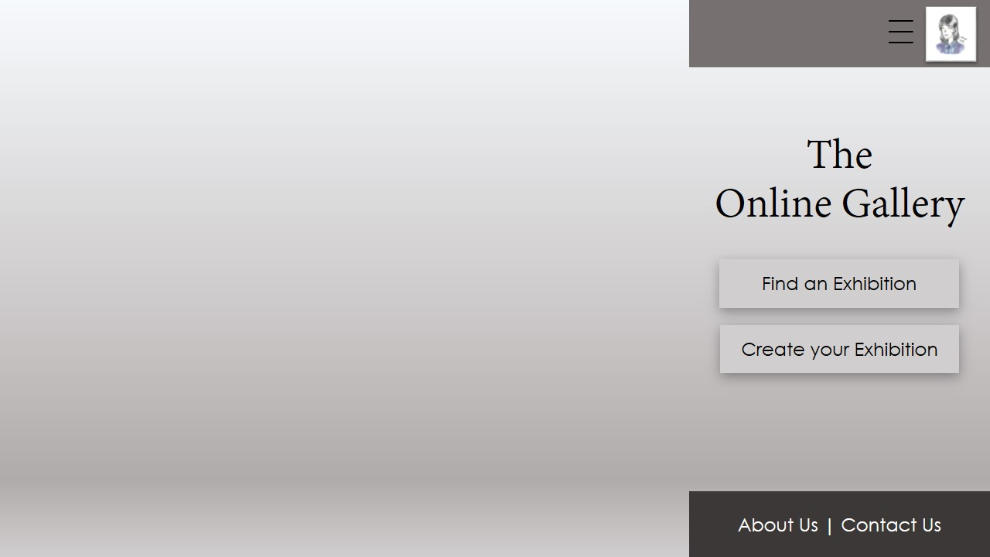

Enter exhibition by clicking on exhibition name

Clicking this will add a drop down with user profile, upload images, edit profile or log out.

Clicking this will add a drop down to ‘log out’ or ‘edit profile’.

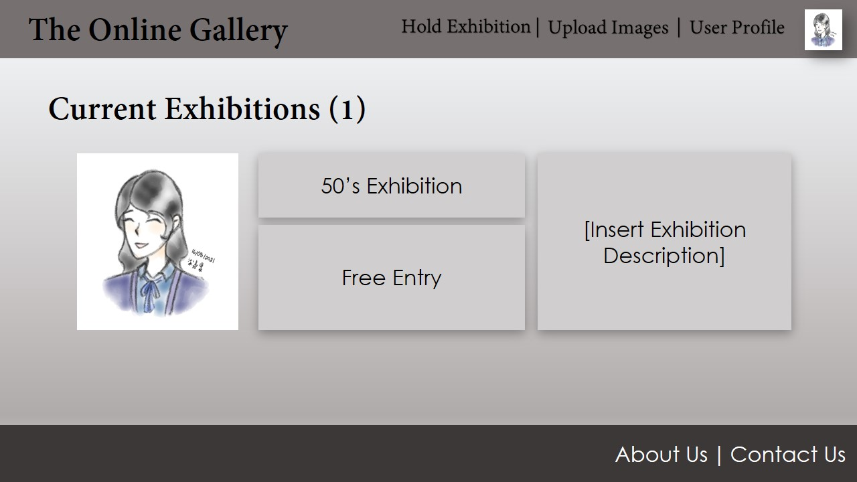

## Asset / Component Connections

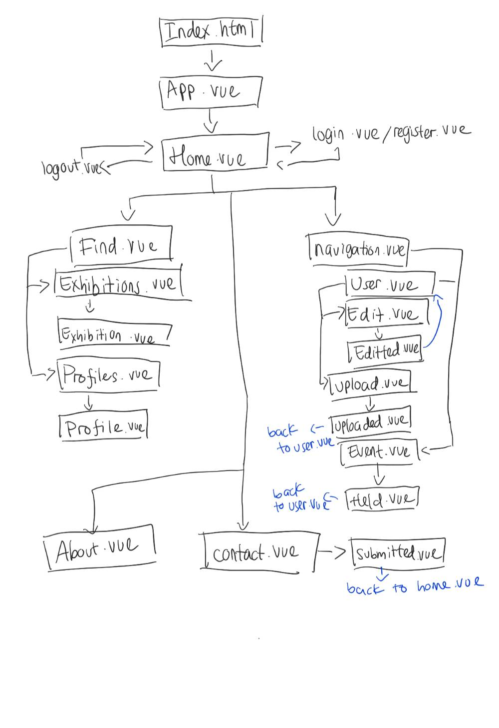

## Concept and Production Plan

* System   
  After the user registered, information will be stored in the website. User can also stay signed in. All uploaded images will be stored in the website as well.   
  In the find feature, user will be able to use filters in order to narrow down the exhibition / artist options, or use a name search to look for specific exhibitions / artists.   
  In the event feature, user will be able to customize their own exhibitions down to background, frame and logo.
* Technical Analysis   
  I will be mainly using html (in Visual Studio Code), JavaScript, CSS, and Vue.js for the website. With Vue.js performing a lot of the interactivity in the website.
* Development Schedule  
  There has been no specific development schedule, however each asset should take about 1-3 days depending on complexity to develop and implement.